After school album

Annual Report (2022-23)
“Education is not a preparation of life; education is life itself”.
- John Dewey

School is the basic foundation of Knowledge being imparted to a child. It gives a chance to children to acquire Knowledge in various fields.
H.M. Sr. Sec. School fosters all round development of a child. We are committed to strive for excellence in each and every endeavor. We inspire our students to become honest, responsible and educated assets to the country. The school nurtures the student’s individual and make them to become solid pillars of the society. We strive to give our students the roots to grow, wings to fly and ambition to serve the nation.
School Activities at Glance:-
The emphasis on holistic development does not only make learning more a joyful Process, it nurtures innate talent and develop skills in youth - an individual asset for a developing nation".
H M. Sr. Sec. School believes in all round development. In order to give our vision a mission, school has been organizing various activities inside and outside of school.
It is said that Earth is Almighty's best Creation. At the same time, it is high time to remind us that environment we live in while bold & brawn, also requires a lot of care and protection. We try to instill nature sentiments in our students. The school celebrated the theme "Nurture Nature”. It was celebrated to make the students aware of various aspects of our environment. Students prepared themselves well for Poem Recitation Competition and Painting Competition on the theme “Nurture Nature”.
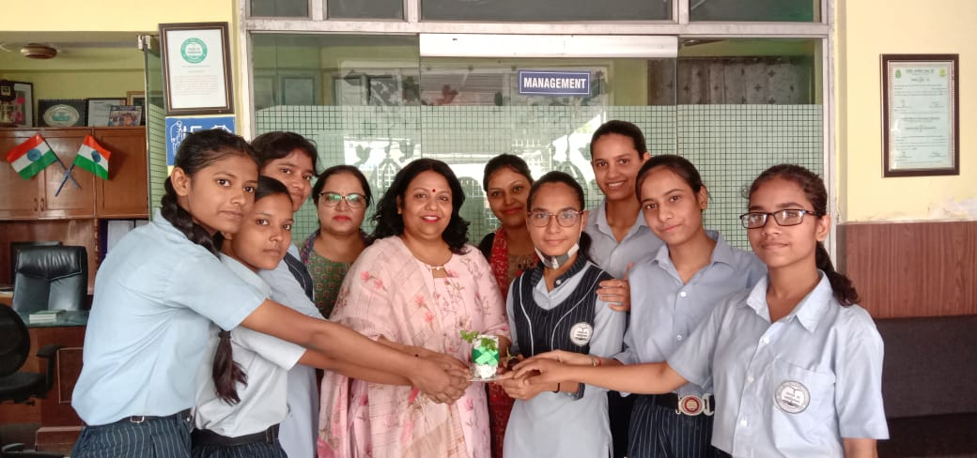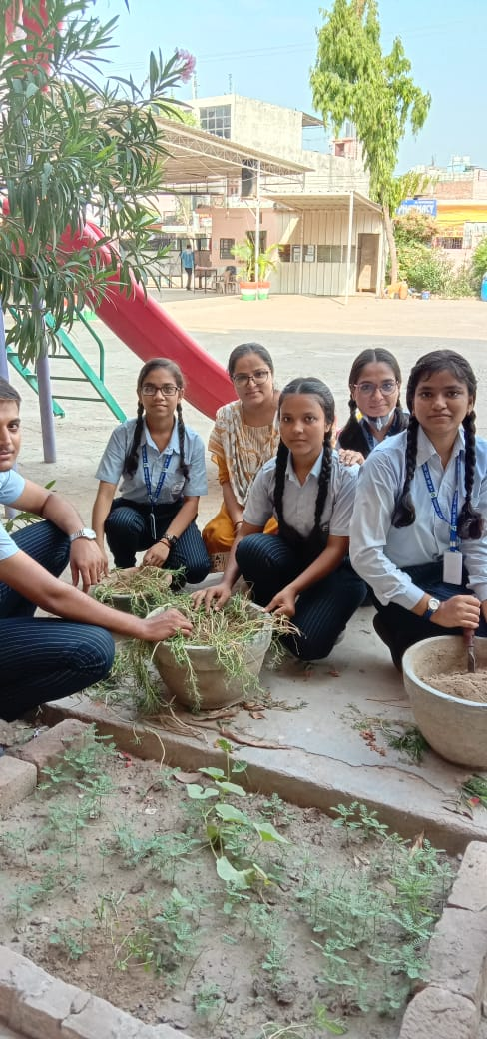

“Nature, thou art God's Creation.
The Benign Mother to all creation”

Mother's day is a special day which is dedicated to all mothers not only in India but all over the world. Students of H.M. Sr. Sec. School found it a right opportunity to thank mothers for their unparalled contribution and unconditional love to make this world a beautiful place to live in. Students from Pre-Primay and Primary Section thanked their mothers by showcasing various activities. Students from (I-V) made beautiful Mother's Day Cards and students of classes (VI-VIII) created admirable Photo Frame for their mothers on the occasion of mothers.
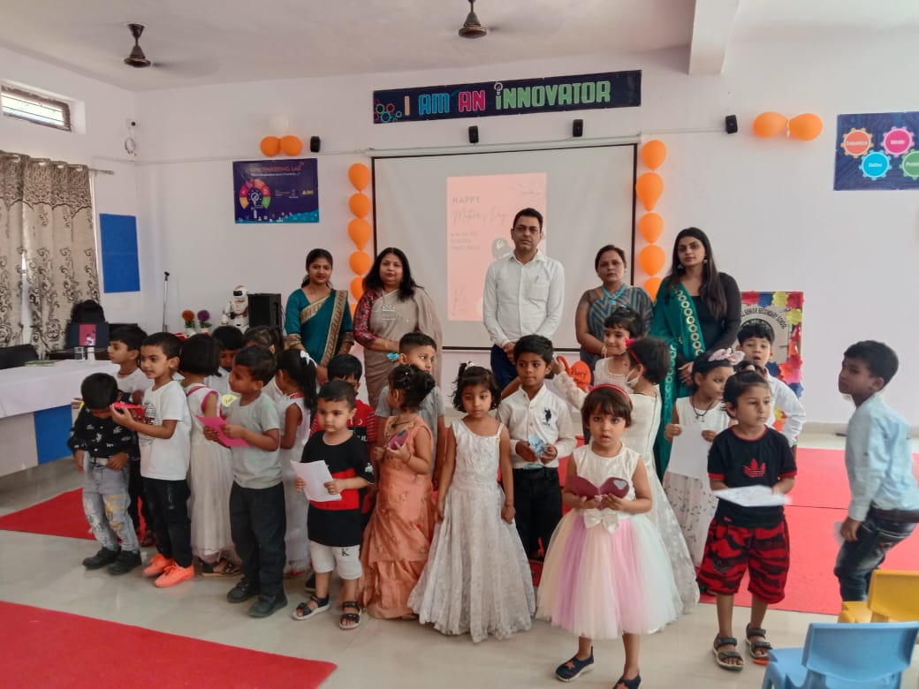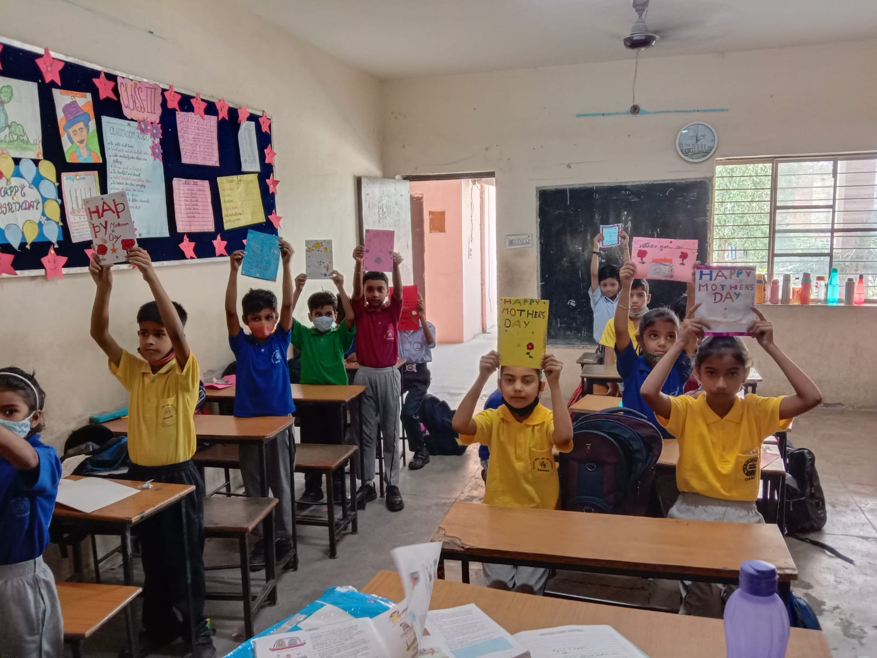
The students celebrated Father's Day with lots of enthusiasm during summer vacation, students made greeting card, sang a song and made beautiful videos.
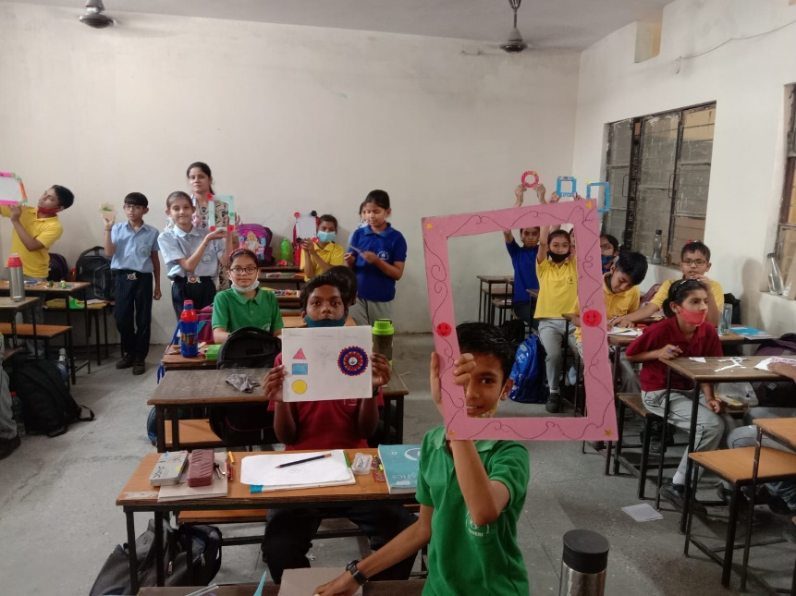

“Yoga is the perfect opportunity to be curious about who you are”
School has always been conscious and focused towards the spiritual, emotional, mental and physical health of its students. Yoga Day was celebrated under the guidance of delegates by Haryana Child welfare Council.
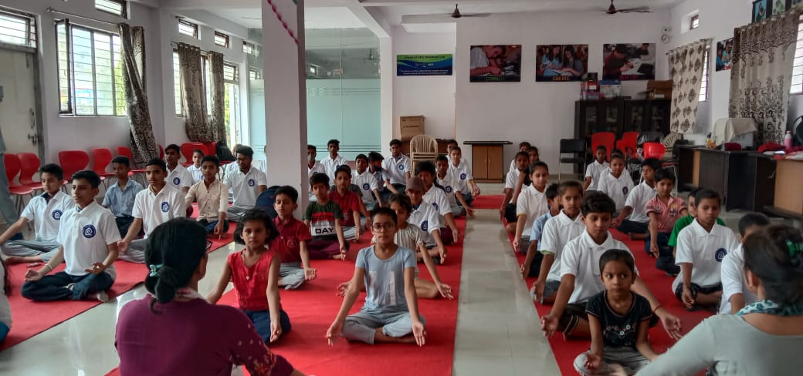
Utilization of time in a fruitful manner is an art and here in the school, students are taught this art is the most fruitful manner. A Summer Camp was organized by school to let the children know how to utilize their time in to fruitful learning. Students learnt dance, musical instruments and vocal training was also imparted to them.
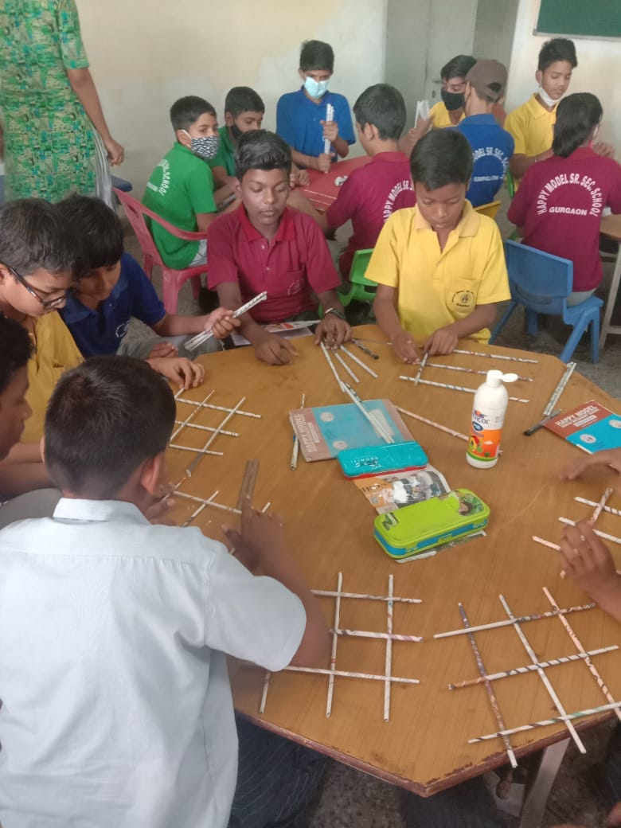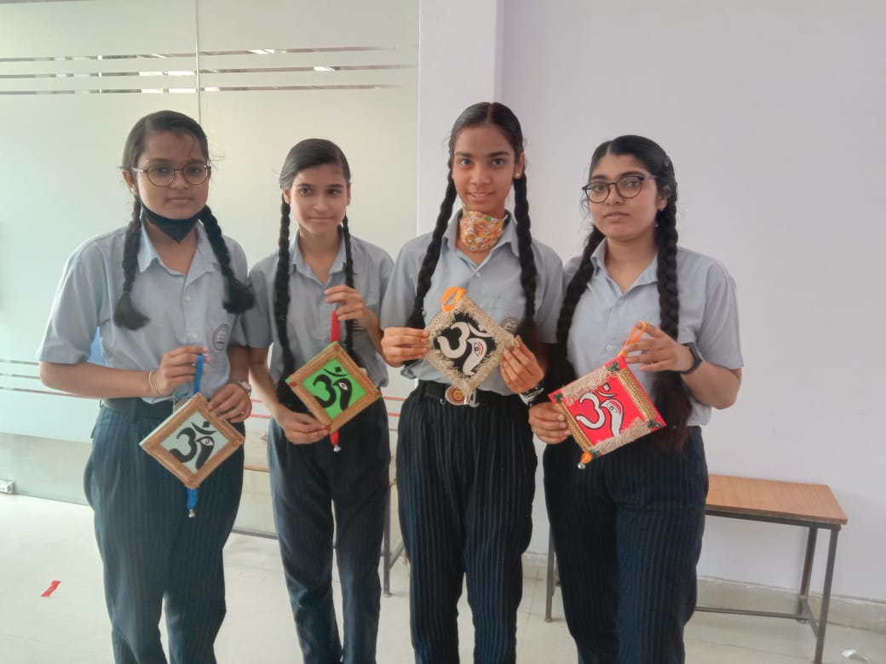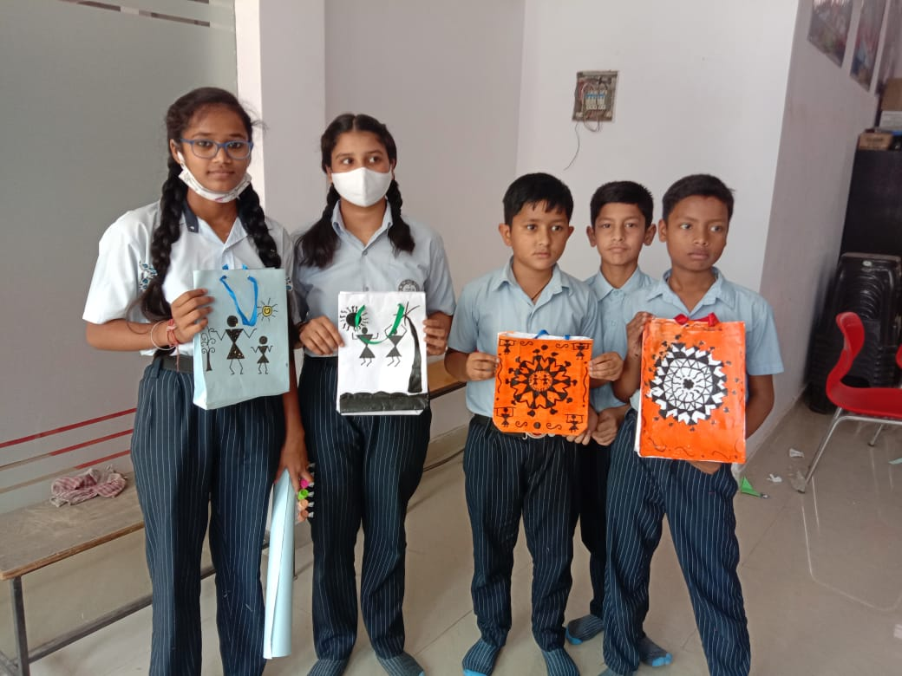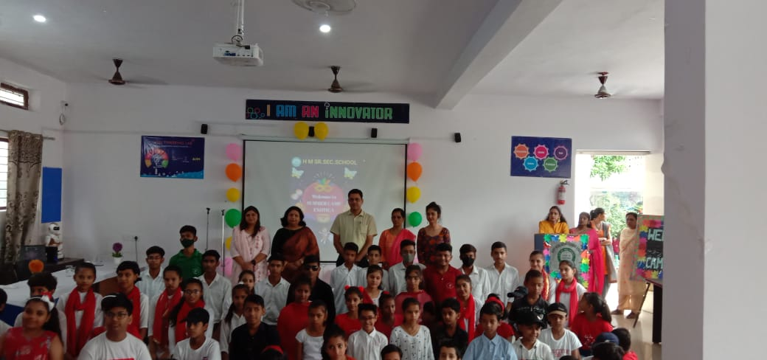
Under the theme “Vasudev Kutumbakam" which means whole world in one family, students of classes (I-V) made beautiful posters and students of classes (VI-VIII) created amiable slogans.
The wave’s whisper to me
Calling me to the soft hand
The water sweeps over my feet
surround where I stand..
As we all know that Water is an elixir to life. To save water by Rain Water Harvesting is the most appreciable method. Students decorated the bulletin boards with appreciable slogans and pictures. Students of classes (I-V) recited beautiful poems on the topic Rainy season and prevented short speech on the theme. “Harvest the Rain, Reap the Gains.”
"Make earth like a diamond and rare, avoid plastic every day and everywhere"
A Plastic Free Awareness Drive was organized in H.M. Sr. Sec. School. Mr. Kuldeep Hindustani (Brand Ambassador of MCG) and Ms. Pramila Singh (Senior Deputy Mayor) were the Chief Guests of the programme. The aim of this drive was to create awareness about the harms of plastic.
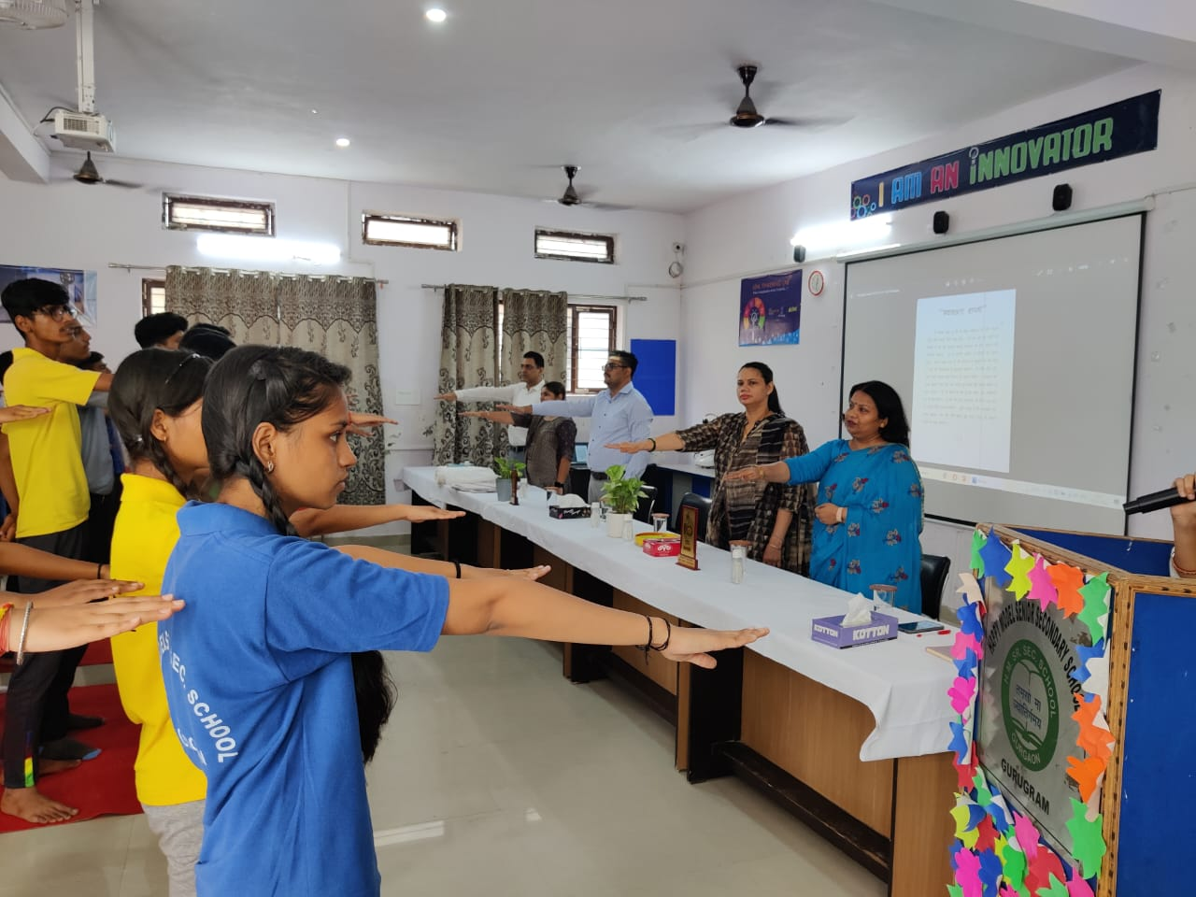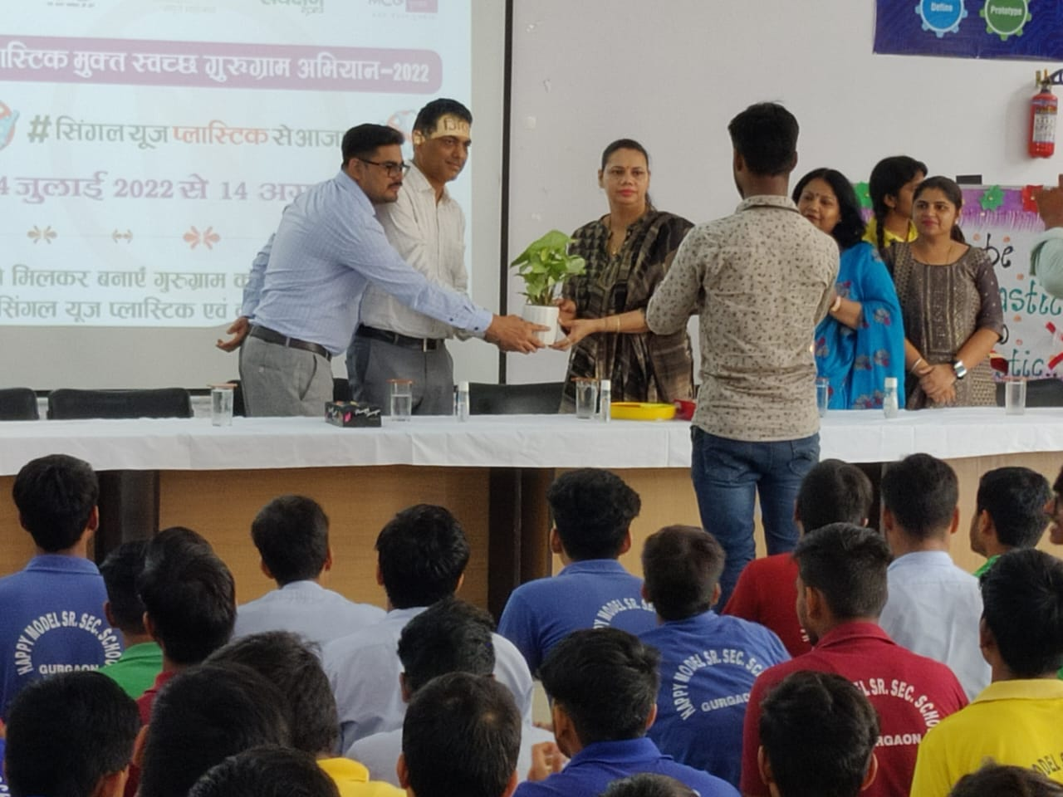

"Patriotism is one of the deepest and noblest emotions of human spirit."
Patriotism is a much required and cherished emotion. To instill the emotion of patriotism, school organized patriotic activities to let the fervor high. On the occasion of Independence Day, students presented Patriotic Group Song, Group Dance, Presentation of Freedom fighters. Colonel Vinod Batra, the Chief Guest for the occasion, appreciated the performance of the students.
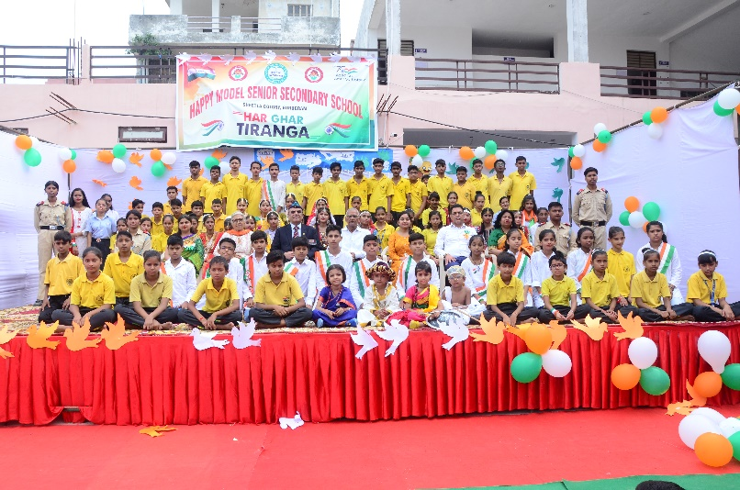

Religiousness is one of the salient features that the school always emphasizes on. Students enjoyed "Rakhi Making Activity” and on the eve of Janmashtami, students decorated flutes and pots in the impressive manner.

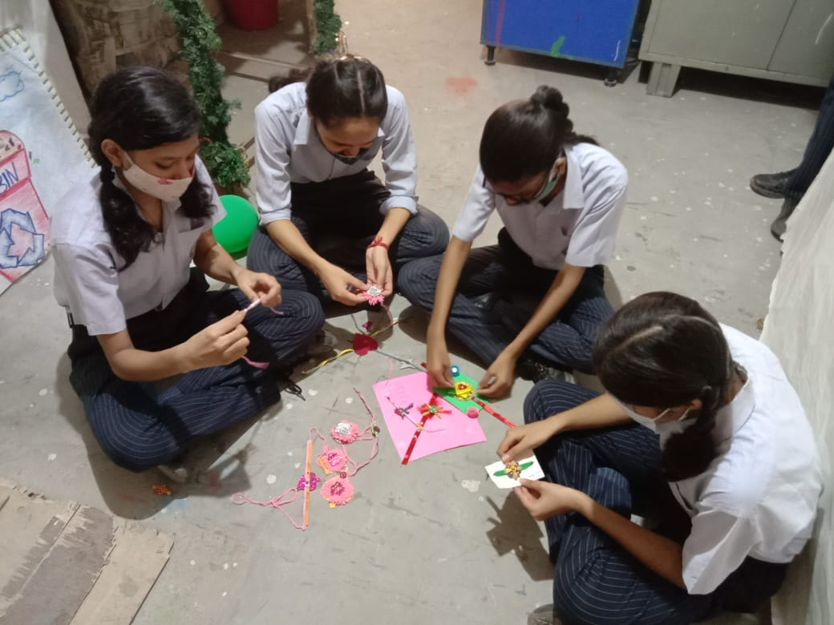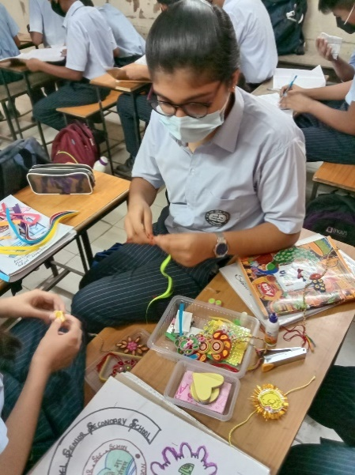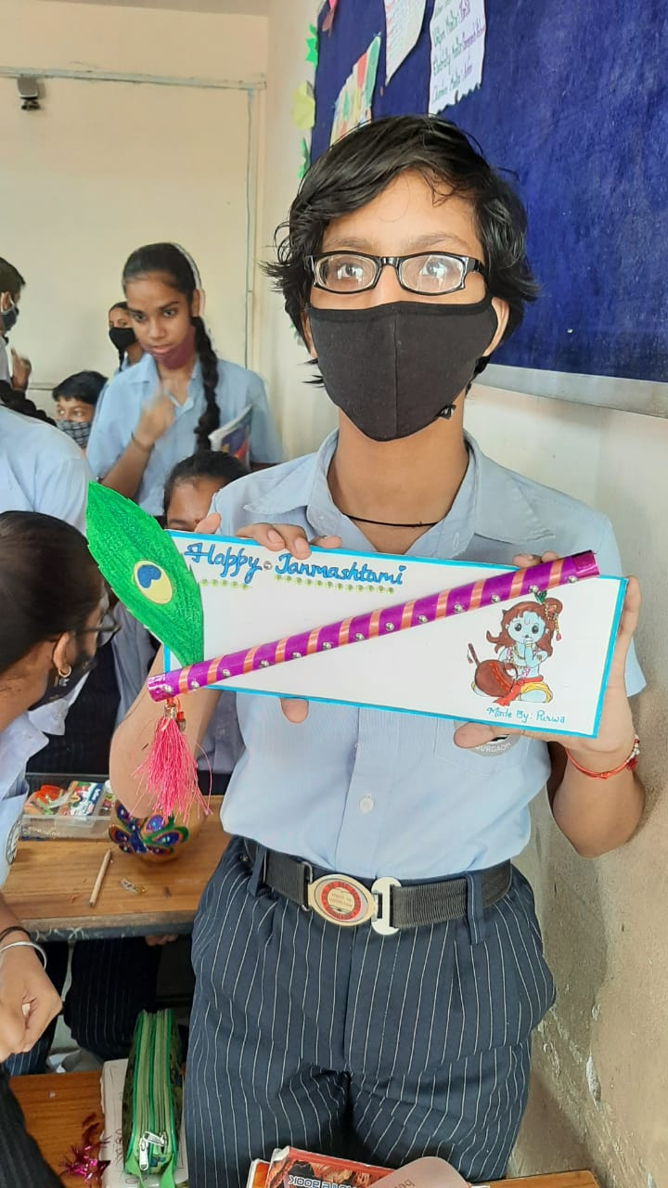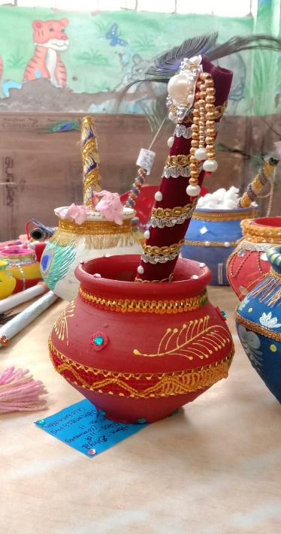
To keep the aura of Independence on, students took part in Patriotic Poem Recitation and Free Hand Drawing on National Symbols enthusiastically.
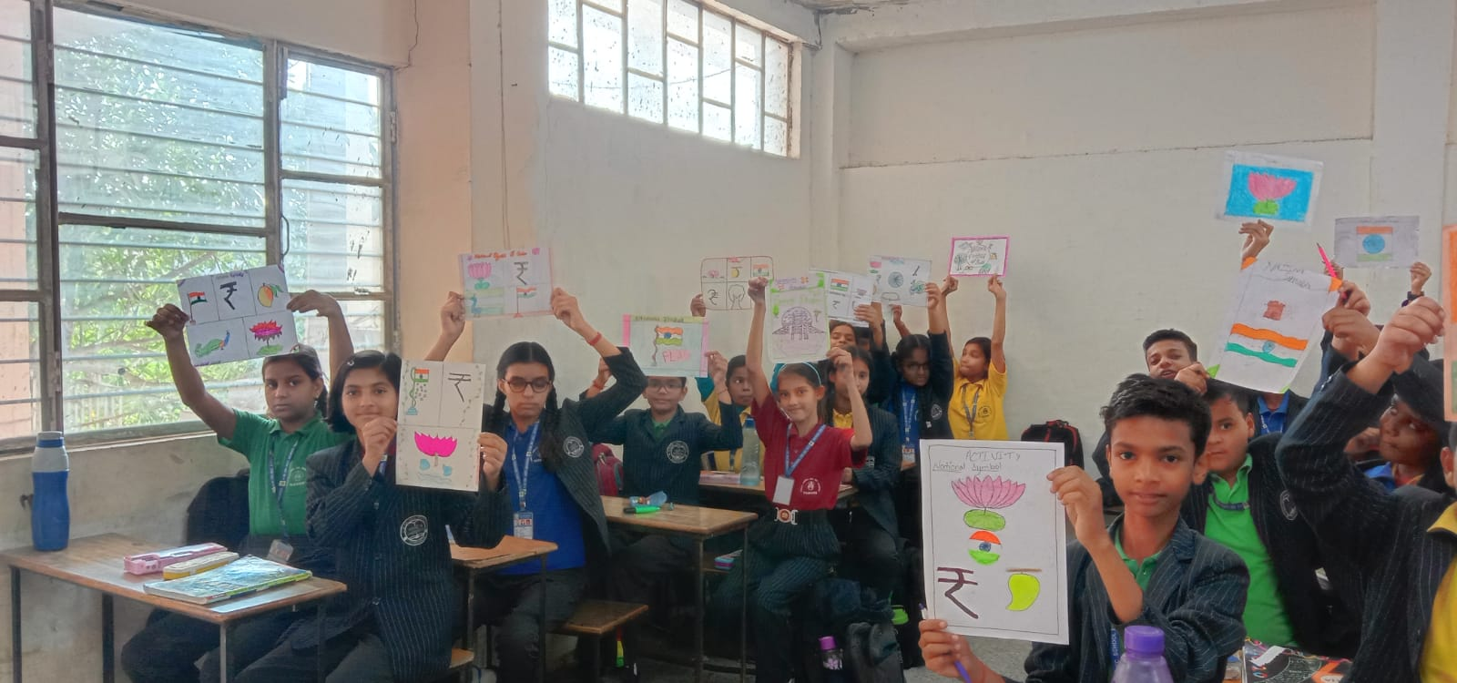
"Deepawali is the not only the festival of lights but also removes the darkness and ignorance from mind and fills it with goodness”
The school celebrated Deepawali in the true sense of festivity. A special assembly was organised on this occasion where students participated in Poem Recitation, Slogan writing and Speech enthusiastically. A mesmerizing performance of Ramayana was showcased by the students in the form of One Act play.

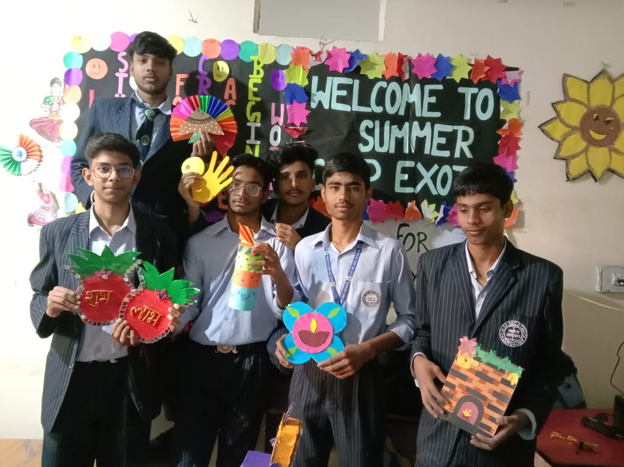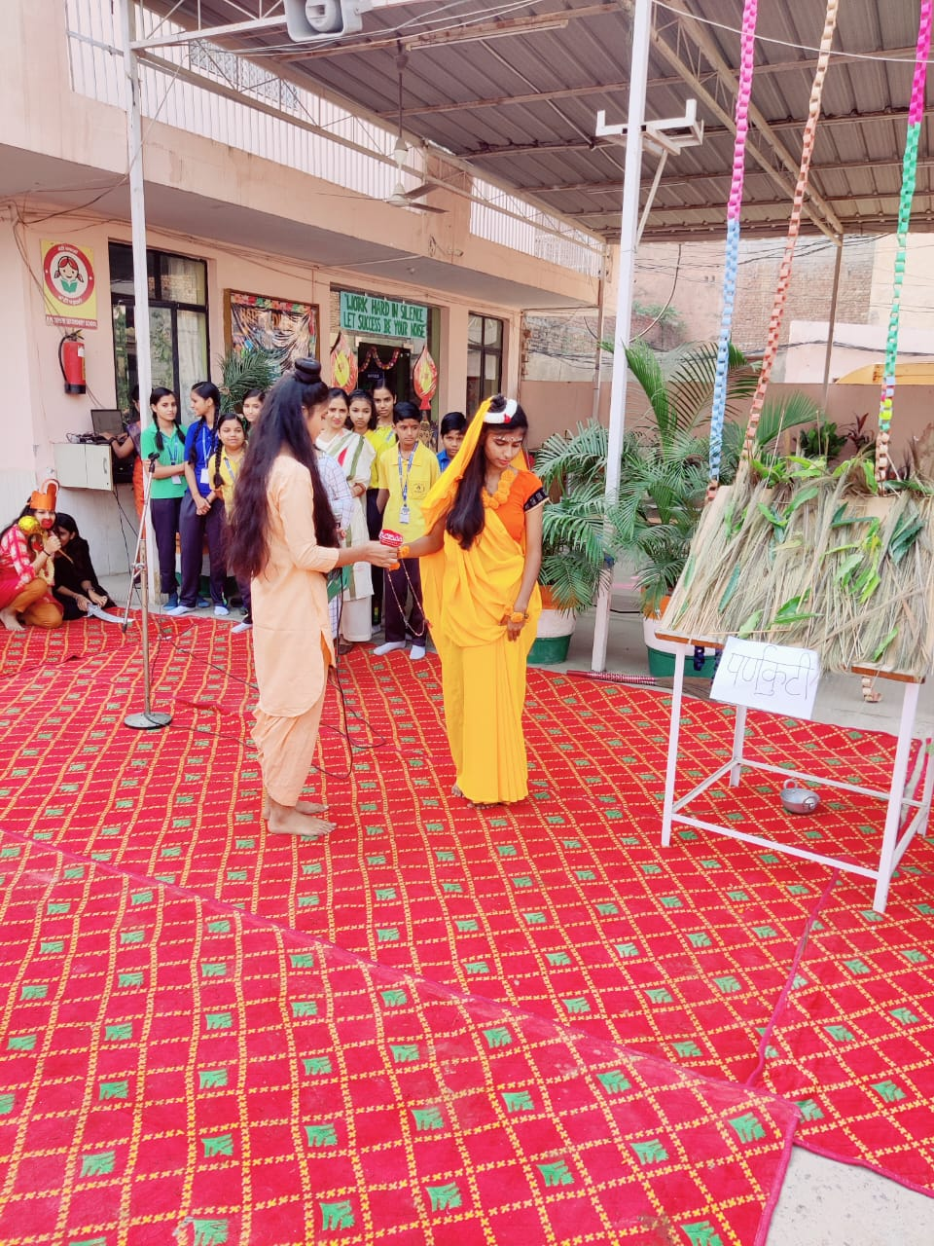
H.M. Sr. Sec. School Celebrated Children's Day with a great pomp and show. Students enjoyed various activities performed by the teacher.
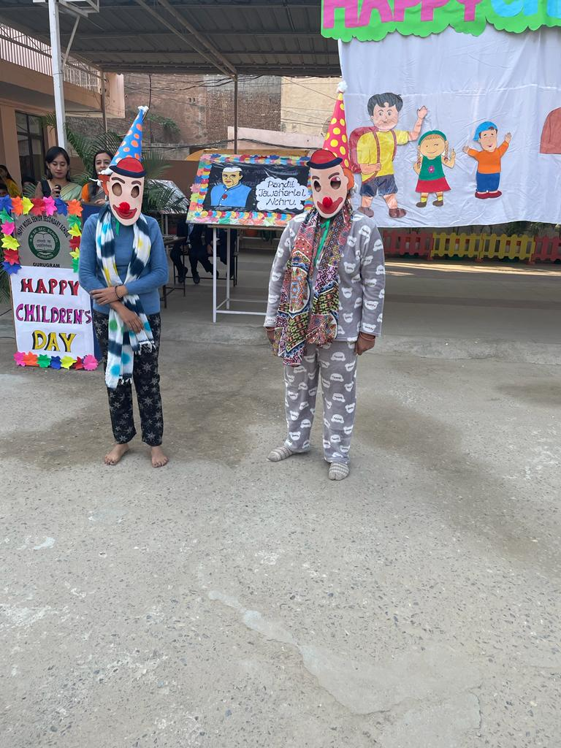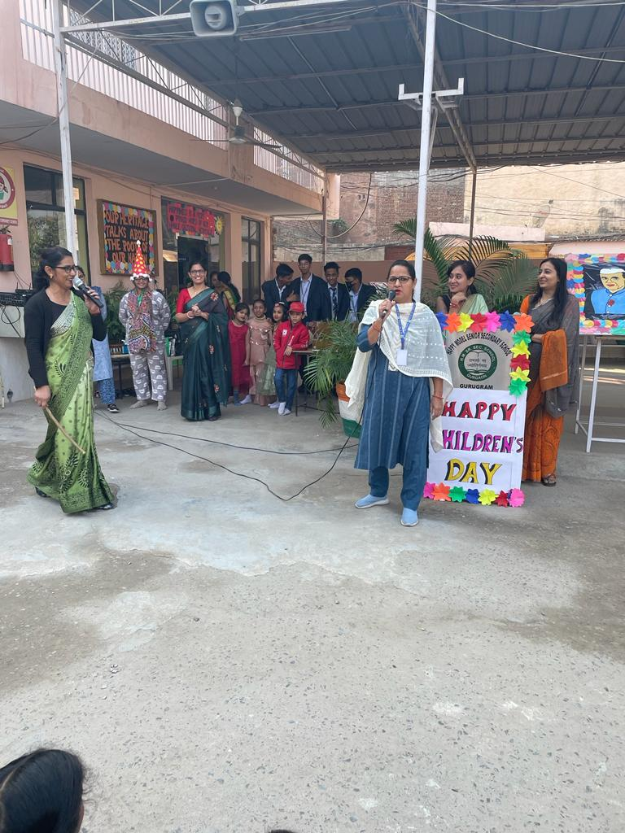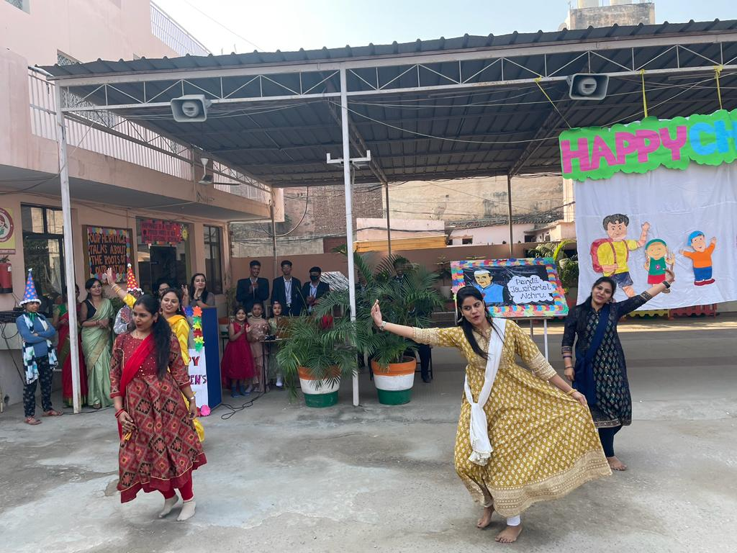

“Our Indian flag does not fly because the wind moves it. It flies due to the deep sense of patriotism and responsibility"
Army Day was celebrated in school with great zeal and fervor. Students participated in various activities such as dance, plays -enactment, group patriotic song. The students showcased marvelous synchronization in “March Past”.

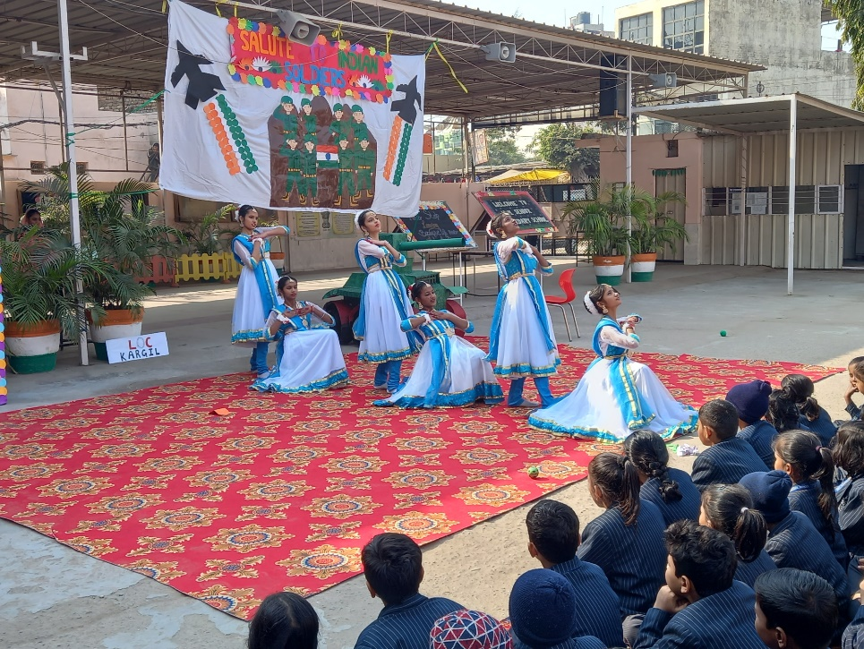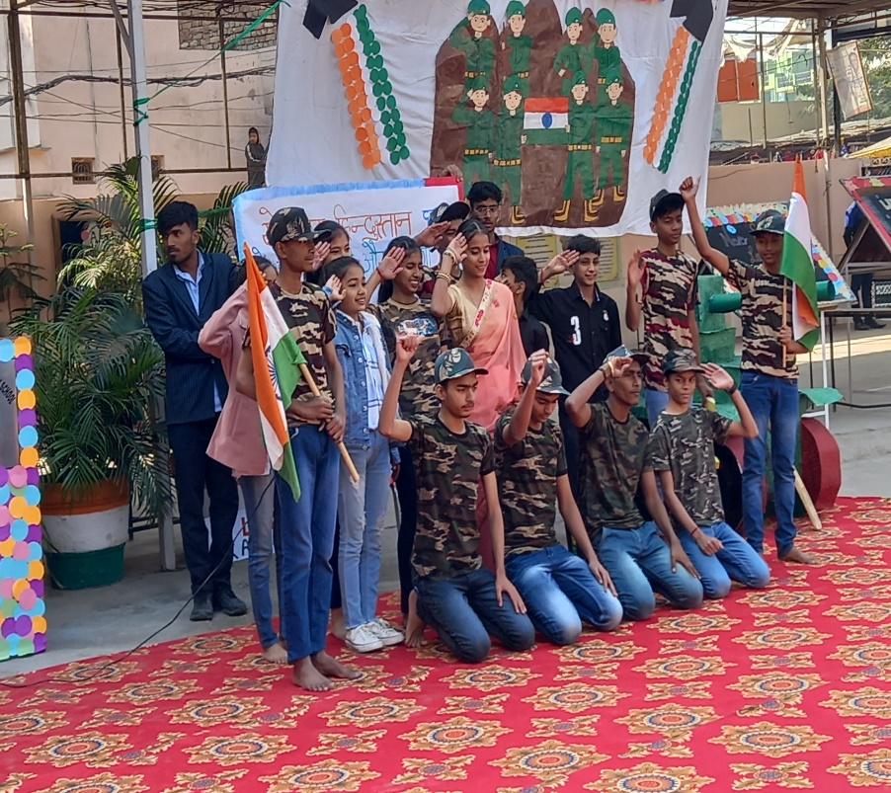
Accolades at a Glance:-
Students of class XII Science were taken to Science Exhibitions held at ‘North Cap University’ and ‘SGT University’ with their innovative ideas on the “Formation & Bio-diesel”. Delegates at the the ‘SGT University’ admired the ideas presented by our student whereas one more feather of laurels was added as the innovative idea about the” Formation of Bio-diesel" was highly applauded at the North Cap university. Studenst bagged the cash prize worth Rs 700/- each and merit certificates were awarded to Lipsita Samal , Kashish Rajak and Kajal Tiwari.
→ ‘Rashtriya Shiksha Samiti (Tohana)’ organised Science Quiz in which Siddharth, student of class VI and Rishabh of class VII remained merit holders.
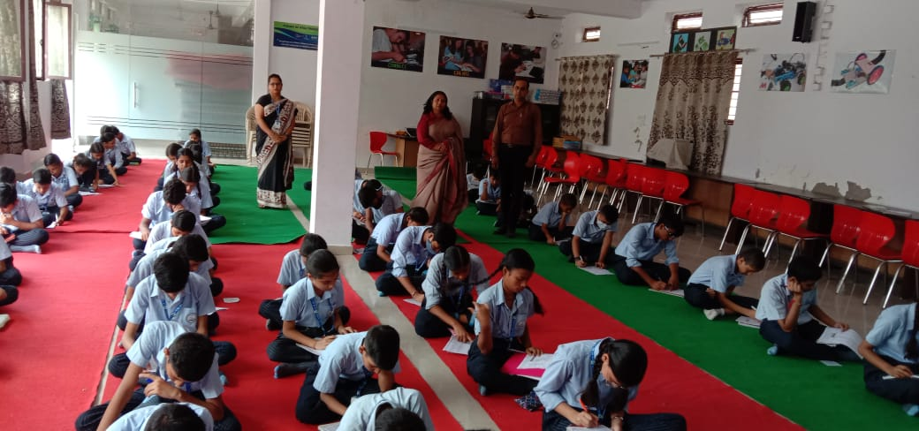
→ ‘Mahatma Gandhi Rajbhasha Hindi Prachar Sanstha’ organised “Akhil Bhartiya Hindi Pariksha”. Sukanya Thapa of class IX bagged ‘Rajbhasha Hindi Gaurav Ratna Award’ and an Appreciate Certificate was also bestowed to her.

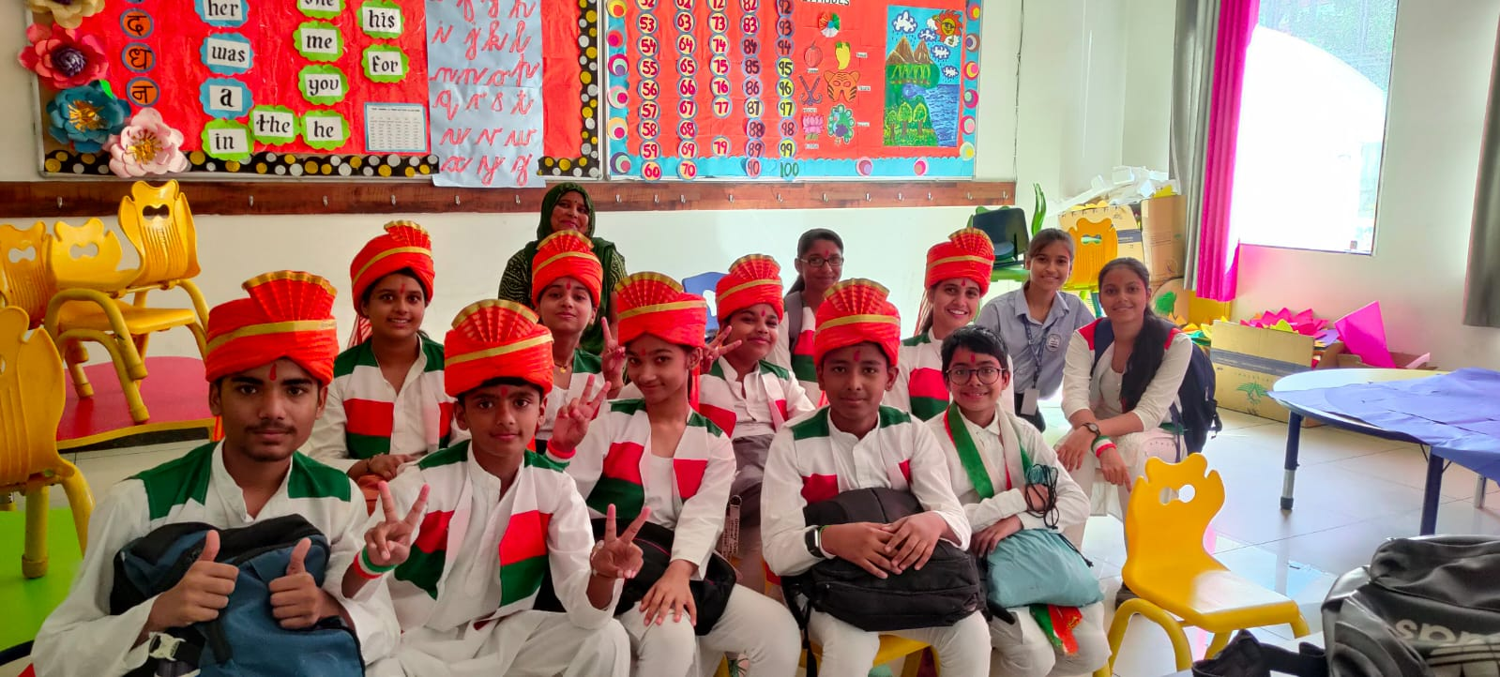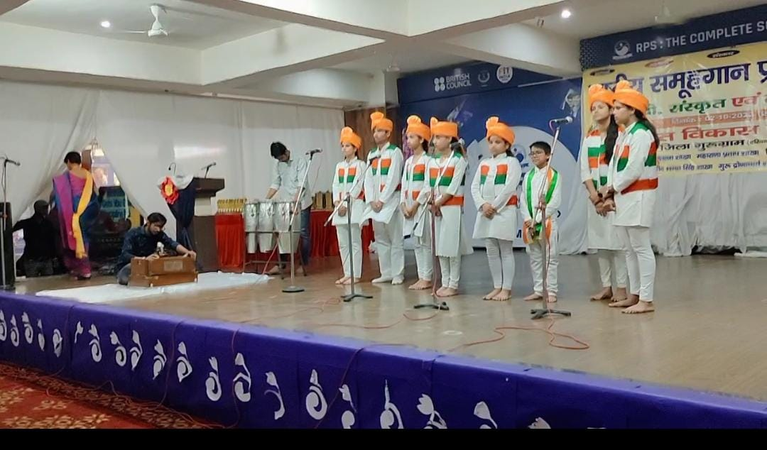

→ Children welfare Association organised Bal Mahotsav on the pious occasion of Children's Day. Lipsita Samal, Class XII Science won third position in English Declamation Competition. Sandhya from class V-A clinched the 2nd position in the Clay Modelling Competition.
